How I Learned to Stop Worrying and Love the Browser
June 2022

LONG AGO:

The ideal playground I had when I was a child (now perpetually elusive):
- An Apple II that booted directly to BASIC.
- Simple programs with a fixed (limited) pixel grid, able to draw lines, dots, circles, squares.
  - TEXTGRID
    - 40 x 48 text (or 80 x 48 in high-res mode)
  - GRAPHICS
    - 140 x 192 (16 colors)
    - 560 x 192 (monochrome)
- 16 color palette
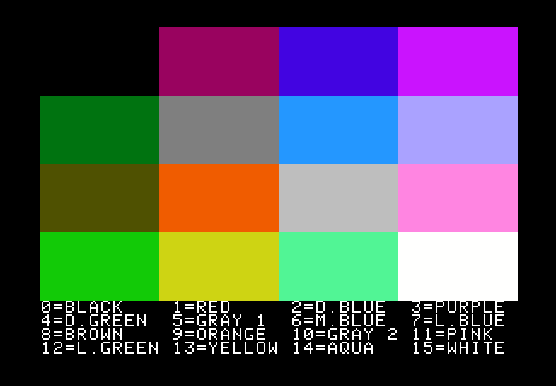
- Simple sounds (buzzing speaker at various pitches)
- random number generation
- loops, arrays, etc.

The browser can do all this, and better, and with so many more features (enough to create a modern-day playground that rivals what I had as a kid, by far!) In other words, the browser has the potential of being my "dream computer" that I'm always preoccupied with thinking about (or wishing I had). And even beyond that, web applications present the LOWEST BARRIER TO ENTRY of all the possible ways to distribute a program. In short, I may actually be able to get my games played...

HTML5's CANVAS ELEMENT:

The main tool is HTML5's <canvas> element, and all its utility via JavaScript and CSS.

But it's not a straightforward road. It's not a simple matter of declraing a 320 x 240 canvas and drawing away to your hearts content. The unfortunate side-effect of using the browser as your rendering engine is it does a LOT of work for you, always interjecting its own hand in things, trying its best to make things look "better" (which often results in blurry images).

ALIASING:

Def. "In computer graphics, the jagged, or saw-toothed appearance of curved or diagonal lines on a low-resolution monitor."

The problem is, today's monitors are of such high resolution (DPI, or dots per inch), that anti-aliasing is "on" by default, resulting in blurry lines (if you zoom in, you'll see related colors, often darker, "blending" the lines into the canvas - its looks horrible if you're going for an old-school, pixelated look with crisp lines with all the jaggies.)

Turning this feature off is browser dependent and hardly seems to work as advertized. Frustrating to no end.

VECTOR GRAPHICS:

Another complication is that the drawing coordinates you give <canvas> aren't "pixel" numbers, they are vector graphics, which will require a mapping to pixels that is not at all straightforward.

If you have a vertical line that has an x value of 3, for example, it will actualy be CENTERED on 3, so the line itself will extend from 2.5 to 3.5. How the hell would you map that to actual pixels? Easy, you fill in all of the 2 column and then all of the 3 column, just to cover your bases. You start to see the messiness involved here.

DPI:

A typical computer monitor has 96 DPI. Its common to see 72 DPI as the recommended "opptimal" resolution ("Increasing the DPI won’t make the image look any better, it’ll just make the file larger, which will probably slow down the website when it loads or the file when it opens.").

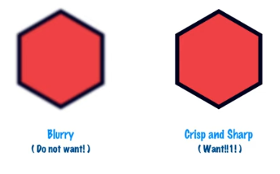

The default of <canvas> is 72 DPI. But today's displays and phone screens often have far more pixels per inch.

THE SOLUTION: BRESENHAM ALGORITHM

Delcare the <canvas> with (css) width and height 320 x 240, but stretch the canvas to a larger size by scaling it with (also css) scale(). Draw lines by implementing the Bresenham algorithm and draw the lines pixel by pixel (using fillRect(x,y,1,1)).

The New Toolbox:

- Use HTML5's <canvas> element and declare it to be a certain size (say 320 x 240).
- Use CSS's width and height parameters to scale the final image. All program rendering is done to the original (320 x 240) dimensions though.
- Using the canvas's drawing context to do all the work (ctx), the basic most fundamental drawing can be done with two calls:
  - ctx.fillStyle = "#FF0000";
  - ctx.fillRect(x, y, 1, 1);
- A simple implementation of Bresenham's algorithm can be used to draw lines that are cris:
  - ctx.fillStyle = "#00FF00";
  - plotLine(x1, y1, x2, y2);
- This uses a custom "setPixel" function which uses fillRect to draw a single pixel:
  - ctx.fillStyle = "#0000FF";
  - setPixel(x,y);
- Color palettes have already been defined! There are 140 web safe colors that all browsers support, with names already defined! Here is a small set of the most basic colors:
- black #000000
- gray #808080
- silver #c0c0c0
- white #ffffff
- maroon #800000
- red #ff0000
- purple #800080
- fuchsia #ff00ff
- green #008000
- lime #00ff00
- olive #808000
- yellow #ffff00
- navy #000080
- blue #0000ff
- teal #008080
- aqua #0000ff
- orange #ffa500
- Sprites
  - let s = new Image();
  - s.src = "cat.bmp";
  - s.onload = () => { ctx.drawImage(s, 5, 5); };
- Text
  - Unfortunately, the canvas's built in font and fillText utilities result in anti-aliased text (and also a bit unintuitive x,y placement).
  - The solution: bitmaps of each and every letter
  - Commodore 64 font = 8x8
    - file "c64_font_size.png"
    - each row = 16 glyphs
    - 8 rows total

